INTRODUCTION
“Submarine Force Library & Museum Association for a fun filled day of golf at Lake of Isles, FOXWOODS, North Stonington, CT and support the Submarine Capital of the world! Your support will aid SFLMA in fulfilling their individual mission and shared vision of preserving the proud history and past achievements of the Submarine Force. Don’t miss out on this great opportunity to have a day of fun, golf and prizes while enjoying the camaraderie of fellow submariners and submarine force supporters, while helping us make this event a great success!!

Mission Statement
To collect, preserve and interpret the history of the United States Naval Submarine Force in order to honor veterans and to educate naval personnel and the public in the heritage and traditions of the US Submarine Force and its relationship to America’s freedom.

Vision Statement
The museum strives to become the Nation’s top destination showcasing outstanding collections and innovative, tangible exhibits that celebrate the Honor, Courage and Commitment of submariners defending their country and citizens.
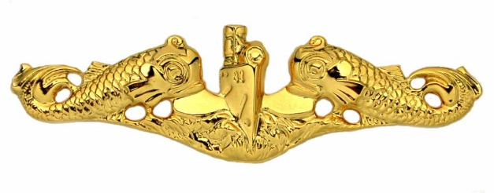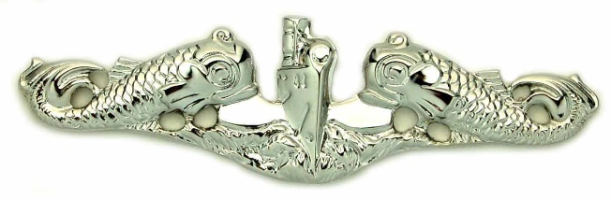

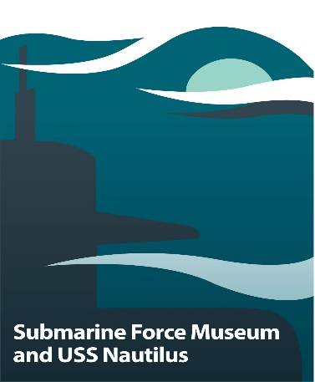

Originally established as "The Submarine Library" by the Electric Boat Division of General Dynamics Corporation in 1955, the Library gained respect for its considerable archival and research value. In April 1964, Electric Boat Division donated the entirety of its historical submarine library holdings to the Navy and relocated it to the Submarine Base New London, in Groton, Connecticut. The name "Submarine Force Library and Museum" was formally adopted in 1969. The Submarine Force Library and Museum Association Inc. (SFLMA) was formed as a non-profit, tax-exempt, organization and incorporated in 1972 to achieve the educational and charitable purposes enumerated in its Certificate of Incorporation.
In the early 1980's, the idea of returning USS NAUTILUS SSN 571, the world's first nuclear propelled submarine, to Groton, Connecticut, began to take shape. The SFLMA Executive Board recognized the significant advantages that would accrue to co-locating the Library and Museum with this historic ship and in 1984, the CONNECTICUT NAUTILUS COMMITTEE was formed to raise funds to bring this idea to fruition. The committee was successful in achieving the design, construction and outfitting of a 14,000 square foot facility on the banks of the Thames River in Groton and received funding from the State of Connecticut and individual and corporate sources. This new facility opened in April 1986.
In late 1997 the Association undertook the task of building a much needed 13,465 square foot addition to the current museum, which had not received any major improvements since its opening. In 1998 the Association launched Campaign 2000 to raise $4 million in funds to expand and improve the Submarine Force Library and Museum. Building of the new addition commenced in late 1998, was completed in early 2000 and was officially opened to the public on 28 April 2000 in conjunction with the Centennial Celebration of the United States Submarine Force.
Museum admission is free. All profits from Association membership, fundraising events and the Museum Store go to supporting the work of the Museum including new accessions, exhibit upgrades and Museum enhancements.
Player Registration Includes

Green Fees
Cart Fee
Range Balls
Continental Breakfast
Grilled Lunch Buffet
2 drink tickets
Registration begins at 0800
Shotgun start at 0930
4 Man Scramble Format
Award Ceremony and lunch after the round

